 |  | AERODYNAMICS  The AER Canada Newsletter  A publication of the Association for Education and Rehabilitation  of the Blind and Visually Impaired
June 2021 | Volume 7, Number 2
NOW BOARDING
IN THIS ISSUE

NOW BOARDING
1 – Spring into Action, Sara Bennett, Editor

BUSINESS CLASS
1 - AER News
2 - NE/AER 2021 Conference Goes Virtual
2 - Come to the World Blindness Summit!
3 - Vision Conference Moves to July 2022, Brian Allen, Chair, VISPA
4 - Call for Papers: Connecting the Dots Conference
4 - Calendar of Events

ECONOMY CLASS
5 - Applications Now Open for CNIB Scholarships!

ARRIVALS & DEPARTURES
5 - ScripTalk Audio Prescription Labels!

ALL SYSTEMS GO
6 - Free Access to BlindSquare for All Canadians!

PILOTS & PROJECTS
7 - AFB’s Second Access and Engagement Report

COAST TO COAST TO COAST
8 - The Cost of Vision Loss in Canada

Spring into Action
By Sara Bennett, Editor
Welcome to the June 2021 edition of AERODYNAMICS!
As spring moves towards summer and as Canada’s individual provinces and territories slowly begin to reopen after COVID-19, I hope this newsletter finds you well and ready for the opportunities that are ahead, even if the first opportunity you take is a well-deserved vacation! Opportunities for rest and relaxation, recreation and entertainment are just as important as those work opportunities. You will find opportunities in this newsletter. If possible, act on them as soon as possible because some have imminent deadlines.
The submission deadline for the September 2021 AERODYNAMICS is August 25, 2021. As always, you can email questions, comments, and ideas to me at: saralb@sympatico.ca
BUSINESS CLASS

Extra! Extra! AER News
- The Association for Education and Rehabilitation of the Blind and Visually Impaired (AER) is excited to announce a scholarship for grad student applicants studying for a career in the field of Orientation & Mobility or Teachers of the Visually Impaired. We are planning on opening the second year of this AER Scholarship in the mid-to late summer of 2021. The application will be posted here at that time: https://aerbvi.org/resources/aer-scholarships/
- The AER eLearning Center is excited to announce that for every weekday in June, there will be something new added to our library of professional development opportunities! This includes pre-recorded sessions from other AER members, live webinars by AER Divisions, and many chances to pursue your continuing education credits!
Keep up with the latest by following us on Facebook and Twitter. View our entire calendar of upcoming live events and search for recorded courses to fit your needs.
AER Membership benefits include special Member Pricing on all sessions and CE credits. Be sure to login to your membership account to access these special rates! Contact Megan Doty for any questions or if you would like to present a webinar.

- Remember AER members can also get continuing education hours and receive a 20% discount on all Perkins Self-Paced Tutorials! Access the Perkins School for the Blind Learning Catalogue and choose from nearly 160 self-paced videos! To get started, go to: https://aerbvi.org/professional-development/perkins-e-learning-aer-member-discount/
- And do not forget that AER has implemented new membership dues for Canadian members. Now, when you renew your AER membership, you will automatically be directed to the reduced rates in our online renewal system. Visit us here to log in and renew online. If you prefer to renew with the membership form, simply complete the special Canadian Membership Form and return it to us at memberservices@aerbvi.org or mail to: AER, 5680 King Centre Drive, Suite 600, Alexandria, VA 22315 USA.
NE/AER 2021 Conference Goes Virtual
The Northeast AER Chapter Conference, “Mystical Connections”, originally slated for 2020 and then tentatively rescheduled for November 3-5, 2021, at the Hilton in Mystic, Connecticut, has now gone virtual and will take place November 4-5, 2021, with the theme “Navigating Our Way Together”.

Although the Call for Papers has closed, you can keep abreast of program and registration updates at: https://www.nercve.org/ne/aer-2021-conference

Come to the World Blindness Summit, June 28-30, 2021
The World Blindness Summit (WBS) Madrid 2021 is a global online meeting, with Madrid as the virtual epicentre and hosted by the Organización Nacional de Ciegos Españoles (ONCE) (National Organization of Spanish blind people). This online meeting will include the General Assemblies of the World Blind Union and the International Council for the Education of People with Visual Impairments.
This event promises to be innovative and cutting edge, embracing the benefits of technology, creating the first global and accessible online conference aimed at addressing the significant challenges faced by blind and low vision people resulting from the severe crisis that has arisen from the COVID-19 pandemic.
Over 1,000 blind and visually impaired people from nearly 190 countries from around the world will share their experiences and practices developed over the past five years, and especially those implemented to cope with the effects of the pandemic in all spheres of life.
Registration is free and provides access to some 50 sessions (available in English, Spanish and French) including: The Future of Work, New Working Environments Post COVID-19; Low Vision Innovation, Prends and Advancements in the Prevention of Blindness; Audio Description Around the Globe; Visionary Learning Enabled by Technology; Innovative Approaches to Teacher Education; Climate Change in Education of Persons with Disabilities; Implementing the Marrakesh Treaty: WBU Training Initiative; and COVID-19 Lessons Learnt for a More Inclusive and Accessible World.
To register or for more information, visit: https://www.worldblindnesssummit.com/en/

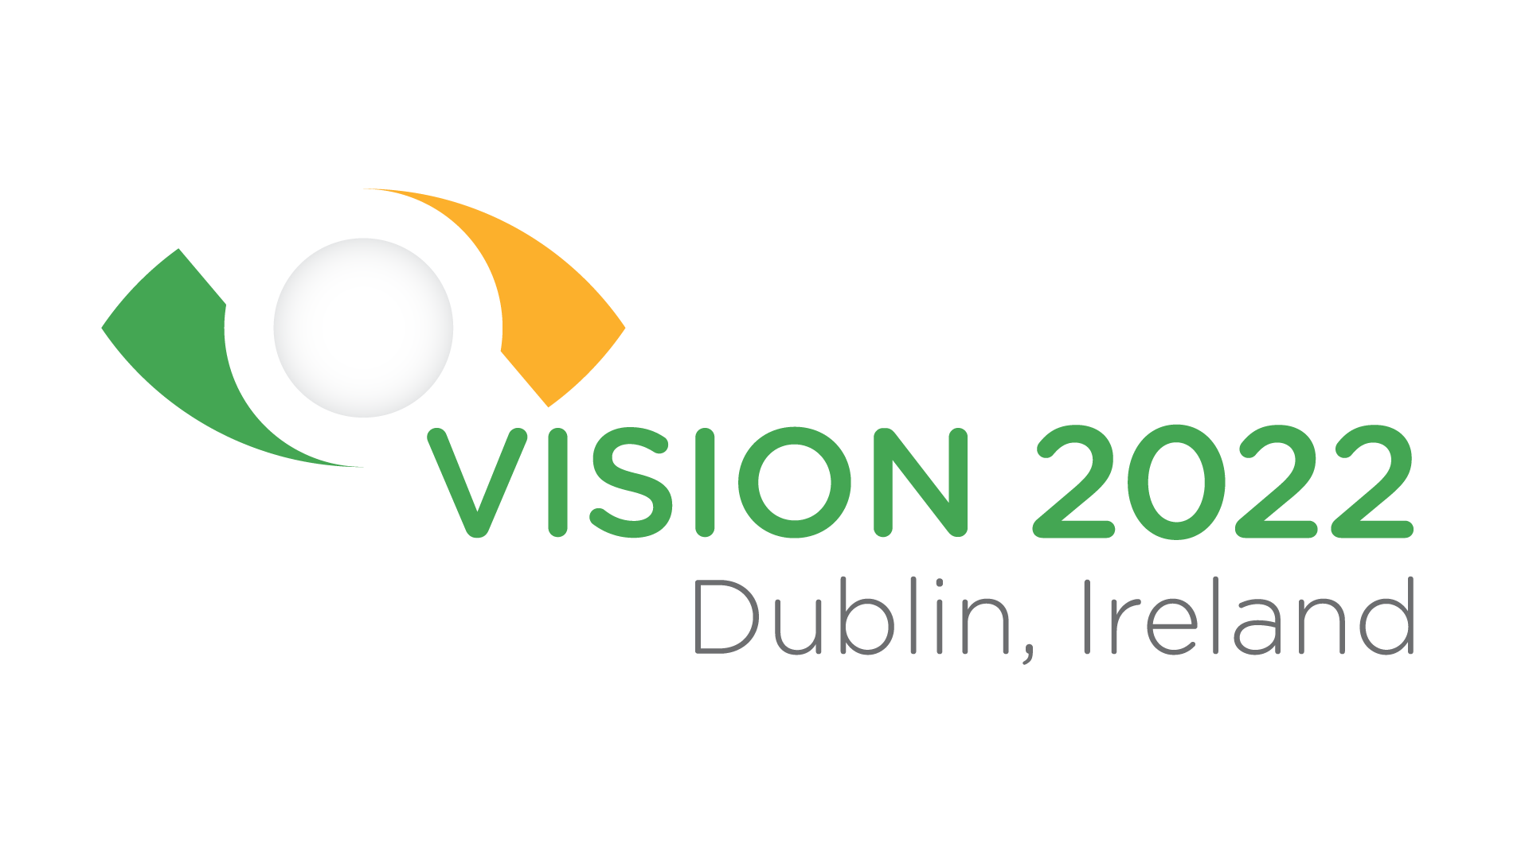
Vision Conference Moves to July 2022

Dear Colleagues,

As the implications of the COVID-19 pandemic became evident in April 2020, we made the very difficult decision to postpone Vision2020 in Dublin, Ireland, and optimistically planned to hold Vision2020+1 exactly a year later, in July 2021. Unfortunately, our hope to see an end to the pandemic and an opportunity for the Low Vision Research and Rehabilitation community to gather safely in person this year is not possible. Due to the ongoing uncertainty around travel and rollout of vaccination programs, we have had to make another difficult decision and further postpone Vision 2020 until July 5-8, 2022, in Dublin.

We are delighted that our Keynote Speakers, Prof. Jane Farrar, Prof. Rupert Bourne and Prof. Pearse Keane will join us in 2022, and we are so appreciative of the support and patience you have shown throughout this uncertain and turbulent time.

Staying connected with you during this time is important to us, so on July 12, 2021, the date we were due to kick off our Vision 2021 Conference in Dublin, we will host a special online event, featuring some excellent Speakers and a Panel Discussion. We want to provide a taste of our conference theme, “Imagining the Impossible”. We also want to give you a sense of our vision and build momentum as we move towards next year’s conference in Dublin.
This will be a free online event, so do not miss it! Place July 12, 2021, 16:00 local time Dublin, UTC+1:00 in your calendar. Register on our website at: https://vision2022dublin.com/
Calendar of Events

June 28-30, 2021 -- World Blindness Summit Madrid 2021, Virtual

October 1-2, 2021 -- Connecting the Dots Conference (English Event), Virtual.

October 15-16, 2021 -- Connecting the Dots Conference (French Event), Virtual.

November 4-5, 2021 – Navigating Our Way Together NE/AER Chapter Conference, Virtual.

November 8-10, 2021 -- Tickling Your Taste Buds Association of Vision Rehabilitation Therapists (AVRT) Conference, Harrisburg, Pennsylvania, USA

January 26-28, 2022 -- International Orientation & Mobility Online Symposium

July 5-8, 2022 -- Imagining the Impossible 13th International Low Vision Conference by the International Society for Low Vision Research & Rehabilitation (ISLRR), Dublin, Ireland.

July 21-25, 2022 – Gateway to Community AER International Conference, St. Louis, Missouri, USA

Brian Allen
Chair, Vision Impaired Service Providers Alliance (VISPA)
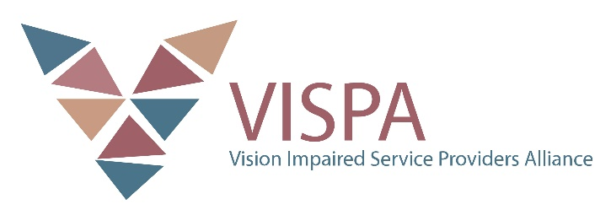

Call for Papers: Connecting the Dots Conference
Connecting the Dots is Canada's largest educational and professional development conference focused on education, technology and employment for people who are blind or partially sighted. Join us virtually for the 2021 conference: October 1-2 (English Event) and October 15-16 (French Event)!

This two-day virtual event will provide opportunities for attendees to:
- learn more about current trends, research, and innovations in the sight loss community at thought-provoking workshops and informative panel discussions,

- meet a community of experts, academics, employers and entrepreneurs from diverse organizations and institutions,

- experience the latest advancements in accessible and assistive technology at workshops and virtual exhibitor booths,

- learn more about programs, services and resources for people impacted by blindness,

- connect with braille transcribers, producers, and specialists to discuss and share all things braille,

- explore opportunities with Come to Work, an innovative program connecting job seekers who are blind or partially sighted with employers who want to discover the full potential of Canada's talent, and engage in structured networking activities,

- access resources and discover tools that empower people who are blind or partially sighted to live life on their own terms, independently, and

- learn more about recruiting employees with sight loss and how to become an accessible and inclusive employer.
Call for Papers: Share your unique perspectives and knowledge! Have an idea for a session, product demo or keynote presentation? Submit a proposal by June 18, 2021!
For more information, including the submission form and contact details, visit:
cnib.ca/connectingthedots

ECONOMY CLASS

Applications Now Open for CNIB Scholarships!
Are you or any of your students pursuing higher learning to advance your educational or professional goals? If so, check out CNIB’s scholarships, bursaries, and other awards.

- CNIB post-secondary scholarships for students pursuing a post-secondary degree, diploma, skilled trades certificate or apprenticeship program.

- CNIB Master’s scholarships encouraging students who are blind or partially sighted to undertake post-graduate studies.

- Scholarships, bursaries and awards available to Canadian students and listed by CNIB but administered or delivered by external organizations, foundations, and corporations.

- CNIB National Youth Council Leadership Award celebrating young people with vision loss who go above and beyond to make a difference in their community.

For further information on these opportunities, visit: http://www.cnib.ca/scholarships. Apply by June 30, 2021!

ARRIVALS & DEPARTURES
ScripTalk Audio Prescription Labels
ScripTalk audible prescription labels enable blind, partially sighted or print-impaired pharmacy patients to hear important prescription label information including dosage, possible side effects and refill information free of charge. With ScripTalk, pharmacists can code prescription labels with Radio Frequency Identification (RFID) technology. Using a small, hand-held base prescription reader called the ScripTalk Station Reader, you can hear important prescription information and instructions read aloud (i.e., an audible label). You can also access talking prescription labels by using En-Vision America’s mobile phone application compatible with the coded prescription labels.
If any of your clients’ daily routines include managing pills, injections, or other medications, ScripTalk can enable them to follow their doctor’s or pharmacist’s instructions safely and independently.
ScripTalk is available over the counter immediately at Sobeys, Lawtons Drugs, Safeway, Foodland, IGA, FreshCo and Thrifty Foods. In British Columbia, ScripTalk RFID labels are also available within 48 hours (or two business days) at all Shoppers Drug Mart outlets, all Walmart pharmacies and pharmacies operating under the Overwaitea Food Group umbrella, which includes Save-On-Foods, Overwaitea Foods, Urban Fare, Price Smart Foods, Price Smart Foods International and Bulkley Valley Wholesale.
To access this service, simply speak with your pharmacist. If your local pharmacy does not yet offer this service, you can connect with En-Vision America, the makers of ScripTalk. En-Vision America is urging all pharmacies to create accessible prescription information. You may also contact Amanda at 1-800-890-1180 or mailto:atolson@envisionamerica.com.
To learn more about ScripTalk, visit En-Vision America online. To see ScripTalk in action in a short video, click here.

ALL SYSTEMS GO
Free Access to BlindSquare for All Canadians!
Toronto, ON (May 20, 2021)–In celebration of Global Accessibility Awareness Day, and in partnership with BlindSquare, CNIB is pleased to announce that the premium paid version of BlindSquare’s navigation and wayfinding app, “BlindSquare EVENT”, is now free to use for all Canadians with sight loss from coast to coast.

BlindSquare is an accessible indoor navigation system that uses physical beacons and GPS data to deliver audio instructions to smartphones. The BlindSquare app, which is available on the Apple App Store, communicates detailed points of interest and provides directions for safe, reliable travel in both indoor and outdoor environments.

Prior to this announcement, access to the premium version of BlindSquare was provided exclusively within select areas, but after today Canadian users can enjoy free and unexpired access to the full and premium version of the app–no matter where they are.

To learn more about BlindSquare, visit: http://www.blindsquare.com. Click here to read the press release.

PILOTS & PROJECTS
AFB Announces Second Access and Engagement Report
Washington, D.C. (May 18, 2021)—The American Foundation for the Blind (AFB) today announced the release of the second Access and Engagement research report, based on the November 2020 survey that delved into the continued impact of COVID-19 on the education of students with visual impairments, their families and the professionals who serve them. The report is a detailed and expanded follow-up to the first Access and Engagement study, published in October 2020, based on data from 1,432 participants collected in spring 2020 during the early days of the pandemic.

Access and Engagement II: An Examination of How the COVID-19 Pandemic Continued to Impact Students with Visual Impairments, Their Families, and Professionals Nine Months Later investigates how the education of students with visual impairments in the United States and Canada continued to be affected nine months into the pandemic.

Key findings include:
- Regardless of where early intervention services were delivered, most family members reported feeling overwhelmed, especially as they needed to juggle multiple roles.

- Some family members of preschool-aged children found that changes from online to hybrid to in-person made it difficult for their child to learn, but others found that during the pandemic, their child’s skills were increasing.

- As of November 2020, 58% of professionals were able to reach between 90% and 100% of their students’ families, with 42% of professionals reaching less than 90% of students’ families.

- Four out of ten professionals reported that up to 25% of their students were on the low end of the digital divide.

- Family members and professionals reported that many educational apps and websites were inaccessible or not fully usable for students who were blind or had low vision. Chromebooks especially presented accessibility challenges.

- During the pandemic, many TVIs reported it was challenging, if not impossible, to coordinate with the classroom teacher in order to prepare and/or get materials to students attending school virtually in time for the lesson.

The report also includes a series of recommendations, categorized by the importance of teamwork, ensuring full participation in education, full access to digital learning and mental health support, to name just a few. Click here to read the full press release.

COAST TO COAST TO COAST
The Cost of Vision Loss in Canada
Over 1.2 million Canadians are blind, deaf-blind or partially sighted, and the number of Canadians living with vision loss (VL) is growing every day. This has profound implications for individuals, communities, the economy, and our healthcare system.
The Cost of Vision Loss and Blindness in Canada is a new report that provides an up-to-date assessment of the prevalence and cost of vision loss in this country.

The growing VL crisis affects all Canadians and will continue to do so. The report outlines the financial impact vision loss has on individuals, Canadian families, and our health system. This is an urgent crisis, and with the findings of this report it is clear that a National Vision Health Plan is needed to provide access to eye exams, therapies, prevention measures and funding for ongoing research.

The Cost of Vision Loss and Blindness in Canada is a joint initiative of the Canadian Council of the Blind (CCB), Fighting Blindness Canada (FBC), the Canadian Association of Optometrists (CAO) and the Canadian Ophthalmological Society (COS).

For more information, or to read the full report, please visit: http://www.stopvisionloss.ca

*****

AERODYNAMICS, the AER Canada Newsletter, is published four times per year—in March, June, September, and December. Please send all items for publication to the Editor at saralb@sympatico.ca by February 25 for the March issue, May 25 for the June issue, August 25 for the September issue, and November 25 for the December issue.

Views herein represent those of the authors and not necessarily those of AER, its Board of Directors, staff, members, or Editor. Likewise, any products or services mentioned do not necessarily represent endorsement.
Editor: Sara Bennett


Association for Education and Rehabilitation of the Blind and Visually Impaired | 5680 King Centre Drive,
Suite 600, Alexandria, VA 22315 USA | 703-671-4500 | www.aerbvi.org | aer@aerbvi.org

