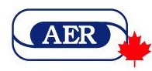 |  | AERODYNAMICS  The AER Canada Newsletter  A publication of the Association for Education and Rehabilitation  of the Blind and Visually Impaired
March 2021 | Volume 7, Number 1
IN THIS ISSUE

NOW BOARDING
1 - Expanding Horizons, Sara Bennett, Editor
1 - Greetings from Texas! Neva Fairchild, AER President
2 - Message from Your Canadian Rep, Laurie Watson

BUSINESS CLASS
3 - AER News
3 - Call for Papers: NE/AER 2021 Conference
4 - Braille-Related Presentations Wanted!
4 - Google and ACVREP Partnership
4 - Calendar of Events

ECONOMY CLASS
5 - Apply for These Scholarships!

ARRIVALS & DEPARTURES
6 - AMD Awareness Month

FLIGHT PATHS
7 - Glasses, Face Masks and Fogging

NOW BOARDING

Expanding Horizons
By Sara Bennett, Editor

As I began to put this issue of AERODYNAMICS together, the news was filled with reports of NASA’s Rover Perseverance and Helicopter Ingenuity landing on Mars. I immediately recalled previous Rovers Spirit, Opportunity, and Curiosity. All are great names for humans’ desire to explore outer space and new worlds. But they are also great words and concepts for exploring an unfamiliar part of town, learning a new skill, overcoming a particularly difficult challenge, setting, and achieving goals and reaching one’s potential, all while firmly planted on planet Earth. That’s what humans—including people who are blind and visually impaired and those who work with them—do each and every day. We each expand our own little world and/or help others to expand theirs.

Please send feedback, ideas and items for the June 2021 issue of AERODYNAMICS to me by May 25, 2021: mailto:saralb@sympatico.ca

Greetings from Texas!
By Neva Fairchild, AER President

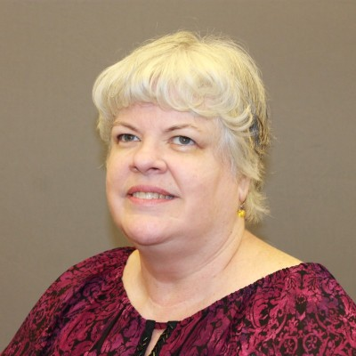
I am delighted to introduce myself to the Canadian members of the Association for Education and Rehabilitation of the Blind and Visually Impaired (AER). I am a Rehabilitation Counsellor by training, and I began my career at the Dallas Lighthouse for the Blind in 1991 as a Vocational Evaluator. Soon after completing my Masters in Rehabilitation Counselling Psychology, I became a Certified Rehabilitation Counsellor and accepted a position with Texas Commission for the Blind as a Vocational Rehabilitation Counsellor. Billy Brookshire, a former AER President, was one of my trainers early in my tenure there. I spent more than 15 years working for the State of Texas, eventually moving to a position working with employers, consumers and their counsellors to find the right assistive technology to accommodate them on the job. Thirteen years ago, I went to work for the American Foundation for the Blind, where I now oversee the Blind Leaders Development Program nationwide.
Throughout my 30 years in the field, AER has been so important to my growth. It has been my resource for ongoing training and networking with others who share my passion. I served as Secretary and then President of the Texas Chapter. I have also served on the boards of three different Divisions over the years. This is my fourth non-consecutive two-year term on the International Board, and I am humbled yet proud to serve as your President. I encourage you to get involved at the Chapter or Division level and build your own network connection by connection. You will never regret it. I get so much more than I give every time I seek to serve AER. I consider myself very blessed to have a career that allows me to lead others who are blind or visually impaired to achieve their dreams, and AER has contributed greatly to my success.

Message from Your Canadian Rep
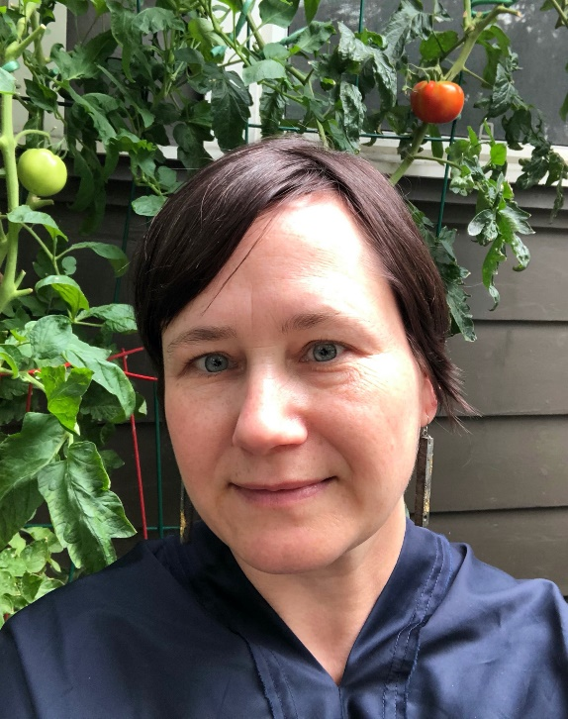
To my Canadian AER colleagues,
Greetings and wishes for health and growth in 2021! I would like to highlight the Association for Education and Rehabilitation of the Blind and Visually Impaired’s (AER) new professional development learning site: https://aerelearning.org
This online platform could provide opportunities for us to plan and provide resources that bring us together as Canadians, in addition to facilitating collaboration with all AER members. I look forward to discussing these exciting possibilities with you.
Please feel free to contact me via telephone at 647-321-6951 or by email at: lauriewatson@me.com.

Sincerely,
Laurie Watson
Teacher of the Visually Impaired, Certified Orientation & Mobility Specialist,
Toronto District School Board

BUSINESS CLASS

Extra! Extra! AER News

- We are excited to announce that our new professional development website is now live! The Association for Education and Rehabilitation of the Blind and Visually Impaired (AER) has put relevant courses at your fingertips--enabling you to keep abreast of new trends in the field--all while qualifying for continuing education (CE) hours! Plus, you can access live or past sessions. AER Membership benefits include special Member Pricing on all sessions and CE credits. Be sure to login to your membership account to access these special rates! Please also let us know if you are interested in presenting a program or sponsoring the site with your organization. Visit the AER eLearning Center today!

- Remember AER members can also get continuing education hours and receive a 20% discount on all Perkins Self-Paced Tutorials! Access the Perkins School for the Blind Learning Catalogue and choose from nearly 160 self-paced videos! To get started, go to: https://aerbvi.org/professional-development/perkins-e-learning-aer-member-discount/

- And don’t forget that AER has implemented new membership dues for Canadian members. Now, when you renew your AER membership, you will automatically be directed to the reduced rates in our online renewal system. Visit us here to log in and renew online. If you prefer to renew with the membership form, simply complete the special Canadian Membership Form and return it to us at memberservices@aerbvi.org or mail to: AER, 5680 King Centre Drive, Suite 600, Alexandria, VA 22315 USA.

Call for Papers: NE/AER 2021 Conference

“Mystical Connections”, the Northeast AER (NE/AER) Chapter Conference originally slated for 2020, has been tentatively rescheduled for November 3-5, 2021, at the Hilton in beautiful Mystic, Connecticut, though it might become a virtual event due to COVID-19.
The organizing committee has some exciting activities planned, as well as informative sessions. If you are interested in submitting a session proposal, we are accepting them until May 15, 2021. The Call for Papers, as well as contact details, can be found at:
https://www.nercve.org/ne/aer-2020-conference

If you live or work in Quebec or Atlantic Canada, we’ll see you there!

Calendar of Events

April 30-May 2, 2021 – Choices and Goals 2021 Canadian Federation of the Blind (CFB) National Convention, Virtual

July 11-15, 2021 -- 13th International Conference of the International Society for Low Vision Research & Rehabilitation (ISLRR), Dublin, Ireland

November 3-5, 2021 -- Mystical Connections NE/AER Chapter Conference, Mystic, Connecticut, USA

November 8-10, 2021 -- Association of Vision Rehabilitation Therapists (AVRT) Virtual Conference

January 26-28, 2022 -- International Orientation & Mobility Online Symposium

July 20-24, 2022 – “Gateway to Community” AER Biennial International Conference, St. Louis, Missouri, USA
Braille-Related Presentations Wanted!

Do you or someone you work with love all things braille?
This is a volunteer opportunity. I’d like to invite you to share your expertise with the Hadley Embracing Braille Discussion Group! Via Zoom, we talk about various topics and issues related to learning, reading and writing braille.

Facebook page: Hadley Embracing Braille and past archives at:
Embracing Braille | Hadley for ideas and the flow of the discussion group.

Please contact Elyse Heinrich at elyseh@hadley.edu with your ideas for a 20-minute presentation on a braille-related topic with Q&A afterwards. 60 minutes total. We have some open Thursdays 11:30am central time slots in March, April and May!

Google and ACVREP Partner to Provide Free Chromebook Accessibility Training

The Academy for Certification of Vision Rehabilitation and Education Professionals (ACVREP) has partnered with Google to provide an in-depth online, on demand and FREE Chromebook Accessibility Certificate program. The online Certificate course is available FREE to both consumers and professionals. Those who successfully complete the training will receive a digital badge that confirms that they are a Chromebook Accessibility Expert.
Professionals will be able to hone their skills in teaching use of the Chromebook and consumers can expand their professional opportunities and be more skilled in using this well-priced computer with built-in accessibility.
The Certificate program expects to launch in March 2021. Watch for more information about the exact launch date and how to apply for the Certificate program on ACVREP’s website:
http://www.acvrep.org
For further information, email Kathleen Zeider at: kzeider@acvrep.org

ECONOMY CLASS

Apply for These Scholarships!

- The 2021 competition for the Edie Mourre Scholarship is now open and will be accepting applications until March 31, 2021. The Edie Mourre Scholarship fund is intended to assist those who are pursuing employment as a braille transcriber or proofreader, or as an educator. Eligible codes include: Unified English Braille, Code braille français uniformisé, music braille or other braille systems. More information on the program and an application form may be found on the Braille Literacy Canada website at: http://www.brailleliteracycanada.ca/en/programs/ediemourre

- The Alliance for Equality of Blind Canadians (AEBC) is now accepting applications for the 2021-2022 academic year. This year we will be awarding two T-Base Communications Scholarships, two AEBC Scholarships and a British Columbia Scholarship, each with a value of $1,000. The application deadline for the 2021 AEBC/T-Base Communications scholarship program is March 26th, 2021. The application package can be downloaded in French and English from: http://www.blindcanadians.ca/programs/scholarship

- The Atlantic Provinces Special Education Authority (APSEA) offers a number of scholarships for post-secondary students who are blind or visually impaired or students who are undertaking post-secondary training in a field related to visual impairment. The application deadline is April 1, 2021. For a list of funds and scholarships available, visit: https://apsea.ca/families-students/scholarships-aid.html

- The National Educational Association of Disabled Students (NEADS) is now accepting applications for the NEADS National Student Awards Program, the NEADS Holly Bartlett Memorial Award, the NEADS Christine Nieder Memorial Award, the Accessible Media Inc. (AMI) Robert Pearson Memorial Scholarship, Canada Post Award and the Alliance for Equality of Blind Canadians (AEBC)–Winnipeg Chapter Memorial Award. These awards are offered to encourage full access to post-secondary education for persons with disabilities enrolled in undergraduate, graduate or professional degree programs at recognized Canadian universities or in certified diploma programs at Canadian colleges. The exact number of scholarships awarded will be subject to the amount of funding received. Apply for all programs through the NEADS website until May 31st, 2021: http://www.neads.ca/en/about/projects/ete2/scholarship/

- CNIB awards post-secondary and master’s scholarships to students who are blind or partially sighted and pursuing post-secondary and post-graduate studies respectively. The next application period for both scholarship programs opens in Spring 2021. Click here for information on the post-secondary program. Click here for updates on the master's program.

ARRIVALS & DEPARTURES

AMD Awareness Month Sheds Light on the Leading Cause of Severe Vision Loss in Older Adults
AMD Primarily Affects Those Over Age 60, but Genetics and Other Risk Factors Play a Role
Toronto, February 9, 2021—Age-related macular degeneration (AMD) is one of the most common eye diseases to cause vision loss after age 60, affecting nearly two million Canadians and accounting for 90% of new cases of legal blindness in the country, according to the Canadian Ophthalmological Society.

AMD affects the central vision and occurs when cells in the macula–a small area of the retina at the back of the eye–break down or deteriorate. While peripheral vision is not affected, one loses the sharp, straight-ahead vision that is necessary for driving, reading, recognizing faces and looking at fine detail.

“Early on, there may not be any noticeable vision loss from age-related macular degeneration, especially if only one eye is affected, but your eye doctor can spot the most common signs before it gets worse,” says Dr. Colin Mann, President of the Canadian Ophthalmological Society. “With treatment, we can delay the progression and prevent further vision loss in about 90% of cases, so it’s critical to have comprehensive eye exams at least once a year, particularly the older you are.”

While age is the biggest factor, the causes of macular degeneration include genetics and a mixture of other health and environmental factors. Particularly at risk are those with blue eyes, heart disease, high blood pressure and high cholesterol. Smokers, people who are overweight or have a family history of the disease may also be more likely to develop AMD.

Depending on which type of age-related macular degeneration someone has, vision loss either happens slowly or quickly. Nine out of ten people with AMD have the atrophic or “Dry” type, which usually progresses slowly over many years. On the other hand, “Wet” AMD is less common but more serious and can lead to vision loss quickly. Delays can result in poorer outcomes, so treating Wet AMD is time sensitive.

Symptoms of AMD
In advanced stages, the more common symptoms of macular degeneration may include:
- Blurry or fuzzy vision that is less clear and it may be hard to read fine print or drive
- Straight lines appear wavy or distorted
- Dark, blurry areas in the center of your vision

Early AMD changes can be detected at home by checking your vision in each eye with the use of an Amsler grid.

Treatment
While there’s no treatment for Dry AMD yet, a high-dose vitamin regimen has been shown to reduce the rate of which people with advanced dry macular degeneration develop Wet AMD, and there are several promising drugs undergoing clinical trials. Wet AMD is more rare and is most commonly treated through injections directly into the eye with drugs that are very effective at causing the abnormal blood vessels to stop growing and leaking. The frequency of injections tapers off after an initial period, but lifelong treatment is required to prevent recurrence and vision loss.

Learn more about AMD, or one of the other four serious eye diseases, by visiting:
seethepossibilities.ca.

FLIGHT PATHS

Glasses, Face Masks and Fogging
Reprinted from the Ontario Association of Optometrists (OAO) website

Editor’s Note: Do any of your glasses-wearing students get frustrated due to their lenses fogging up when wearing a face mask? This is a nuisance for anyone but is of particular concern for those who already have low vision. The tips in the following article might help.

February 5, 2021--The COVID-19 pandemic has, and continues to have, a tremendous impact on the way we navigate our daily lives. One of the changes it has brought about are mandatory face masks or face coverings in indoor public spaces: from grocery stores to on-board public transportation.

As we move toward an optimistic future of vaccines and opening back up, face masks will likely be a part of our “new normal” for at least the foreseeable future. Wearing a mask presents one frustrating issue for glasses-wearers: the fogging up of glasses, particularly aggravated by cold weather. This fog is caused by warm breath escaping from the top of your mask, and lands on the cooler surface of your lens.

OAO member Dr. Wes McCann has a few solutions for those who are balancing the combination of masks and glasses. The easiest solution is to seal down your mask around your nose or cheeks. McCann recommends using surgical tape or other bandage that won’t irritate the skin.

“You can also opt for a mask that has a wire across the nose, so you can tighten the upper edge, meaning less air can escape. You can mould it to your face a little bit more,” explains Dr. McCann. If your mask doesn’t fit your face well, warm air is likely to escape and fog up your lenses. When putting on your mask, make sure to pinch the top of the mask to fit the shape of your nose. If your mask allows it, tighten the sides as well for a good fit. Another benefit to have a well-fitting mask is the better protection it offers you.

Dr. McCann also suggests investing in a pair of lenses with an anti-fog coating, or the cheaper alternative: anti-fog sprays and wipes. “You wipe them in the morning, and they last for about 24 hours,” McCann says. “That’s a more inexpensive option.”

You should also make sure your glasses are fitted properly and get them adjusted so they sit better on your nose or can go on top of your mask.

Some glasses-wearers have found choosing contact lenses rather than glasses when they will be wearing a face mask for a long period of time to be an effective solution.
As we continue to navigate this pandemic, we continue to remain hopeful that the everyday annoyances we face balancing our glasses and face masks to one day be a distant memory.

*****
AERODYNAMICS, the AER Canada Newsletter, is published four times per year—in March, June, September and December. Please send all items for publication to the Editor at saralb@sympatico.ca by February 25 for the March issue, May 25 for the June issue, August 25 for the September issue, and November 25 for the December issue.

Views herein represent those of the authors and not necessarily those of AER, its Board of Directors, staff, members or Editor. Likewise, any products or services mentioned do not necessarily represent endorsement.

Editor: Sara Bennett

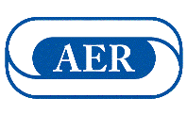
Association for Education and Rehabilitation of the Blind and Visually Impaired | 5680 King Centre Drive,
Suite 600, Alexandria, VA 22315 USA | 703-671-4500 | www.aerbvi.org | aer@aerbvi.org

