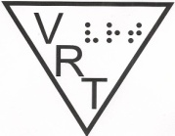
AER Vision Rehabilitation Therapy (VRT) Division
http://vrt.aerbvi.org
VRT News
Winter, 2015

Table of contents:
- Message from the Chair-Ian Shadrick CVRT, CRC
- Mark your Calendars
- Executive Summary: Vision Rehabilitation Therapy Strategic Planning and Advisory Symposium-Lachelle Smith, M.S., CVRT
- Defining Our Role, Professionalizing Our Field (Part 1)-Kendra Farrow, CVRT
- Transitioning to UEB Starts with You-Jennifer Ottowitz, CVRT
Meet a Member:Susan Dalton, CVRT
- VRT Board Contact Information

MESSAGE FROM THE CHAIR
Ian Shadrick, CVRT, CRC

On behalf on the officers of the Vision Rehabilitation Therapy Division, I would like to wish you a happy and healthy new year! We hope that the New Year is full of joy, excitement, and new opportunities and is off to a wonderful start!

As the New Year begins, many of us choose to set resolutions. These can be a wide range of things. No matter the resolution, it is still about making a change in the New Year. This can also apply to professional endeavors as well. Some of these resolutions may include, what can I do differently to be more effective or creative when working with clients? What can I do differently to be more efficient with my documentation or reporting? What can I do to obtain the knowledge and education I need to help me in my work? This can also apply to your involvement in your professional organization. What can I do to become more involved with the VRT Division and with AER?

There are plenty of opportunities to become involved with us in 2015. Renewing your AER membership, attending the 2015 AER Conference in Norfolk, participating in a Mangold seminar or other educational offering from AER and reading AER Report and JVIB are just a start. You may choose to write an article for the "VRT News" newsletter or consider becoming involved with one of our Division committees.

The VRT Division leadership will continue to ask the question "What can we do this year to better help our members?" as well. We hope to provide a webinar to Division members in the early summer on how to stay updated with technology. We look forward to celebrating VRT Week across the world in April (see the announcement of a date change and stay tuned to future communications regarding ways you can promote and celebrate all things VRT). We continue to strive to update our website and develop resources to recruit new professionals. We will be developing some ad hoc committees to revive some of the discussions started during our Boston VRT conference.

We encourage you to contact one of the Division officers with any ideas, suggestions or comments you may have. We want to help you achieve your professional goals and ask that you please help us answer the question "What can we do differently in 2015?"

Sincerely,

Ian Shadrick M.A., M.A., CVRT, CRC
VRT Division Chair

MARK YOUR CALENDARS
- March, 15, 2015 Deadline for articles for next issue of VRT News-send articles to Jennifer Ottowitz
jennifer@hadley.edu
- March 16, 2015 Deadline for abstract submissions for AER Conference on Vision Loss in Older Adults & Veterans: Leveraging Our Collective Wisdom-to submit abstracts, visit
http://aerbvi.org/aerconf2015/presenter_info.htm
- April 12-18, 2015 VRT Appreciation Week-Please note that the dates have changed from June to April to help celebrate the birthdate of Annie Sullivan. Stay tuned for future communications regarding this week of celebration.
- November 4-6, 2015 AER Conference on Vision Loss in Older Adults & Veterans: Leveraging Our Collective Wisdom-For more information, visit the conference website at
http://aerbvi.org/aerconf2015/.

Executive Summary
Vision Rehabilitation Therapy Strategic Planning and Advisory Symposium
Lachelle Smith, M.S., CVRT

Introduction:
This document summarizes the collaborative discussions that took place during the Vision Rehabilitation Therapy, Strategic Planning and Advisory Symposium hosted by Salus University, College of Education and Rehabilitation, Department of Blindness and Low Vision Studies. The symposium was held on the campus of Salus University in Elkins Park, Pennsylvania from April 4, 2014 through April 5, 2014. This report is based on recordings taken from the symposium.

The event was co-sponsored by Salus University and VisionServe Alliance. VisionServe Alliance is an organization comprised of a consortium of Executive Directors/CEOs of 501(c)(3) nonprofits throughout the country that provide services to people with vision loss. VisionServe Alliance partnered with Salus to host this event by providing financial support in an effort to address the severe shortage of VRT professionals and the field’s inability to meet the growing needs of nonprofit organizations and other agencies nationwide.

The consortium of stakeholders was comprised of representatives from personnel preparation programs offering VRT training (Salus University, Northern Illinois University, Western Michigan University, Hunter College and the University of Montreal), consumer organizations (American Council of the Blind and American Foundation for the Blind), private and nonprofit agencies (VisionServe Alliance, representing 100+ private and nonprofit agencies), Veterans Administration, state blindness agencies (Bureau of Blindness and Visual Services and Alabama Department of Rehabilitation Services), membership organizations ( Association for Education and Rehabilitation of the Blind and Visually Impaired [VRT Division and Recruitment and Retention Committee] and Association of Vision Rehabilitation Therapists [formerly known as MACRT]), national certifying body organization (Academy for Certification of Vision Rehabilitation and Education Professionals), and a practicing CVRT (VISIONS services for the Blind and Visually Impaired). Other stakeholders that were invited to participate in the symposium, but were unable to attend were The University of Massachusetts at Boston and The National Federation of the Blind.

Fifteen of the twenty representatives were physically present at the symposium with four representatives attending through the WebEx platform and one representative providing information ahead of the symposium to be shared with the group. Lastly, twenty percent (four) of the attendees had a visual impairment. Therefore, the information provided in this summary reflects the perspectives of all major stakeholders in the field of vision rehabilitation therapy.

Objective:
The purpose of the symposium was to bring together a consortium of stakeholders to address specific challenges faced by the Vision Rehabilitation Therapy Personnel Preparation Programs and the profession at large. Each participant was quite aware of the dire state of VRT and the potential impact it has on its viability as a profession. With the rapid decline in professional preparation programs available to train individuals in the area of VRT and the decreasing number of individuals seeking VRT Certification, some leaders in the field have expressed concern that the profession of VRT has the potential to become extinct in five years or less. The goal of the symposium was to lead the efforts in establishing a framework by which VRT programs and the overall profession can remain relevant, grow in number and transform into the modern profession our present day and future consumers and society need.
This summary will describe the three main topic areas discussed and the proposed strategies and actions this consortium of stakeholders has committed to further investigate, develop and execute.

Process:
Data used to produce the summary was obtained from multiple sources including, but not limited to: an online survey sent to all participating personnel preparation programs, both written and verbal presentations by each consortium stakeholder, written notes from open and break-out strategy sessions and lastly, from the translated recordings of all open strategy sessions.

Main Topic Areas:
The three areas identified as the major challenges facing the VRT profession to date included: Recruitment of Quality Students into the Personnel Preparation Programs, Need for a Clearly Defined Professional Identity and Need for an Updated Curriculum. Please refer to this link to review the complete document.
http://vrt.aerbvi.org/resources.htm under the heading VRT Consortium: Executive Summary of Symposium

Recommendations:
At the conclusion of the VRT strategic Planning and Advisory Symposium, the consortium of stakeholders offered the following recommendations:
- Form subcommittees or working groups to continue to work on each identified challenge: recruitment, professional identity and updated curriculum

- Submit a Position Paper or White Paper detailing the work that was accomplished at the symposium

- Solicit JVIB to host an issue dedicated to VRT

- Investigate the feasibility of creating a consortium training model among the university programs in VRT

- Collaborate with individual vision rehabilitation programs and ACVREP to research the feasibility and process for transitioning to a unified professional title/certification

- Collaborate with AER to update its VRT website and all information relevant to VRT

- Share the symposium’s recommendations with the field: Attend and present on the work of the symposium at future AER conferences

- Create work groups to prepare professional and university curriculum to move towards a health/wellness or medical service model

At the time of this submission, it can be reported that seven of the eight recommendations outlined in this document have been addressed by the consortium.

Updates on the work of the consortium stemming from this Symposium will be shared in future VRT Division newsletters.

Defining Our Role, Professionalizing Our Field (Part 1)
Kendra Farrow, CVRT

Over the past two years I have spent substantial time considering the way an Occupational Therapist (OT) works with persons who have vision loss. Not to say that I hadn’t thought about it before, but this topic became personal when my organization hired an OT who had no background in working in the blindness field. Based on this experience, I developed a presentation about Vision Rehabilitation Therapist (VRT) and OT professionals working together. What I discovered challenged me as a professional and has motivated me to take a stand that I could not have imagined taking a year ago.

What is the difference between a VRT and an OT? A VRT works exclusively with persons who are experiencing vision loss, while an OT is a generalist, working with any person who has any condition which is impeding their participation in life activities. The American Occupational Therapy Association (AOTA) says OTs work to “increase engagement in daily life activities (occupations) that support health and participation in home, school, the workplace, and community life”. Doesn’t that sound familiar? VRTs have a similar job description: to “work to enhance vocational opportunities, independent living, and educational development” (ACVREP). Based solely on definitions, the difference between these two occupations is unclear. Other than specializing in just one disability, what sets VRT services apart? I talked to OT and VRT colleagues and read journal articles and textbooks, but I felt no closer to an answer. Finally I got my hands on an OT assessment, and reviewing this document helped me clarify the differences.

The first difference is that most OTs who work with persons who have vision loss use the same assessment form. In contrast, if we polled five different VRTs, we would likely find that they each use a different form. For OTs, some of this uniformity comes from Medicare requirements, and it also provides a basic structure which gives uniformity to services provided.

Second, the OT assessment uses a number coding system for indicating functioning level. In my professional experience I wrote down long detailed answers to the functioning of my clients. Later I developed a checklist so I would not have to write down so many notes. I have looked at many VRT assessment forms, and only two used a number system, and these use a more complex scale than the one that appears on the OT form. The OT number coding system is simple: 1= unable to complete the task, 2= completes task with difficulty or assistance, and 3= completes task independently. “Not Applicable” is also a possible answer for each idem in the assessment form. The numbers are used to calculate an overall percentage of the client’s life that is being effected by their vision loss.

Another difference between the OT and VRT systems is that the OT assessment tool is used at both the beginning and end of services. By calculating a score twice, changes in the client’s life that indicate improvement through OT services can be demonstrated. This is where VRTs fall short. We might know that our clients are safer in the kitchen than they were before and that they can complete tasks they couldn’t do before we provided services, but such anecdotal evidence doesn’t carry the weight that a number does. While numbers don’t convey the emotional improvements our clients experience, numbers speak loudest to those who hold the purse strings. When I first started working in the field in 1999 the economy was great, but as the financial climate has changed, so has the need to prove results with numbers and quantifiable results.

Another unique feature of the assessment form used by OTs is that the list of tasks is looked at from the visual perspective. Reading tasks are rated from most to least visually demanding, from reading the telephone directory to the least demanding task, reading a clock or telephone. In the hand-eye coordination category, the most visually demanding is caring for clothing/threading a needle and the least visually demanding is dressing/locating clothing items and matching them. The last category on the form is mobility, which has four tasks, the hardest of which is dining out while the least visually demanding is avoiding collisions/tripping. In some ways I like the idea of ranking the items on the assessment form, and I am sure we could have some great discussions on how to rank the items. My concern is what OTs do with a person who has no usable vision. Being without usable vision does not mean that an individual can’t do some of these tasks. As VRTs, we know this, but for an OT, the only way to complete these tasks is through visual means.

To me the greatest difference between an OT and a VRT is that one profession teaches clients how to use their limited vision and the other teaches clients how to use any method that works safely and efficiently to complete tasks. When an OT uses the term “low vision services,” she is referring to all the services she provides to persons with vision loss. When I as a VRT use the term “low vision services,” I am speaking about specific services related to low vision aids and strategies such as increasing contrast. “Low vision services” does not encompass the whole of what I do.

Several months ago I had a long email discussion with an OT colleague who has had extensive training in working with individuals who have vision loss. She even helps teach courses for other OTs who are seeking certification in the field. I asked her if part of their training included completing activities while wearing a blindfold. She replied that they did not although they did many tasks wearing simulators. I explained to her how my education included a focus on training while wearing a blindfold, with the idea that, if one can complete a task with no vision at all, one can surely accomplish that same task with some vision. I have come to believe that this is the element of our training that sets us apart. It is also the reason we teach braille and OTs do not.

In closing, I believe that the services we provide as VRTs are unique and highly specialized. Despite dropping numbers of personal preparation programs, we are needed and must take the initiative to prove that our services make a difference. In my effort to develop a practical next step, I would like to suggest that to professionalize our field we should:
- Develop an assessment tool that collects quantitative, not just qualitative, results, and
- Unify ourselves as a profession around that tool and work with our organizations to adopt that tool as the standard.

If we do this we will be prepared to defend the importance of what we do, we will create a sense of uniformity for our services, and we will unify ourselves by reaching a common practical goal. In addition, the power of numbers will develop more opportunities to publish based on the results of our services, and by publishing we can take an important step to professionalize our field.

We invite you to share your feedback and suggestions on this topic with Kendra by emailing her at
kfarrow@colled.msstate.edu

We also invite you to write an article for the newsletter regarding your suggestions on how we can further define our role.

Kendra works for the National Research and Training Center on Blindness and Low Vision at Mississippi State University. She was also a presenter at the 2014 AER International Conference in San Antonio.

Transitioning to UEB Starts with You
Jennifer Ottowitz, CVRT

In November 2012, the Braille Authority of North America (BANA) voted to adopt the Unified English Braille code (UEB) as the official braille code for literary braille in the United States. The target date of January 4, 2016 was set as the tipping point for which most of the transition to the new code will occur. Many organizations, agencies and professionals have already begun the transition process. Transition and implementation plans are being developed and address both the needs of the professionals who will be teaching braille and transcribing braille materials as well as the needs of those learning braille. Many of these plans, however, address the needs of school-aged children with few addressing the needs of adults who will be learning to use the new braille code.

Does your agency or organization have a plan to transition to UEB? Do you have your own personal plan of how you will transition to the teaching and use of UEB? The transition starts with you. You can help your agency or organization develop a plan if one does not currently exist. You will be crucial in implementing the plan and your input is extremely valuable.

There are several parts to a transition plan. These include what steps need to be taken as well as a timeline for completing them. The first involves you learning to read and write UEB. Do you already know the new code? There are many excellent resources available to help you learn the new code including the rules governing the use of symbols and contractions along with the differences between UEB and the current code (English Braille American Edition or EBAE). More and more resources are becoming available but here are just a few.
- The Hadley School for the Blind offers a "Transitioning to Unified English Braille" course for professionals and family members as well as for individuals who are blind or visually impaired. This six-lesson course is designed for those who already know how to read and write EBAE contracted braille. The course is available in large print and braille with the online version available in summer 2015. The course is available free of charge to family members and for those who are blind or visually impaired. Through a partnership with the American Printing House for the Blind, this course is being offered free of charge to professionals for calendar year 2015 and is available for continuing education credit from ACVREP. For more information or to enroll, visit http://hadley.edu/ShowCourseDetail.asp?courseid=UEB-121
- "UEB Online" is an online course developed by the Royal Institute for Deaf and Blind Children’s Renwick Centre in Australia. It consists of 30 lessons and no prior knowledge of braille is required. The course is offered free of charge and is designed for sighted professionals and family members. Please note that the course is not accessible with screen reading software. For more information, visit http://uebonline.org/

- The instructional book "Ashcroft's Programmed Instruction: Unified English Braille" along with "Ashcroft's Programmed Instruction Instructor's Manual" and "Ashcroft's Programmed Instruction Companion Reader: Unified English Braille" are available from Scalars Publishing at http://www.scalarspublishing.com/
- The website of Braille Literacy Canada (BLC) has information about a joint UEB transcription course available through BLC and CNIB. This website also provides information on the Canadian transition to UEB as well as links to other resources for training. Visit brailleliteracycanada.gov

- You may learn how to format and emboss braille documents in UEB using the Duxbury software program by visiting www.duxburysystems.com.

Once you have learned the new code, you must determine when you will begin teaching it to the clients with whom you work and what training materials you will use. Since not many of the instructional curricula for adults have been revised to UEB, you can help encourage publishers to develop and/or revise more updated curricula which teach UEB. You may wish to get involved with this development/revision yourself. Some other resources of braille materials which can be used for instruction include
- The UEB version of the "McDuffy Reader: A Primer for Adults" is available from the National Federation of the Blind. This instructional book teaches both uncontracted and contracted UEB. To order, email independencemarket@nfb.org or via phone at (410) 659-9314, extension 2216.
- The BANA website has several documents available for free download which are written in UEB. To access these documents, visit their website at http://www.brailleauthority.org/ueb.html

You may wish to not only address the needs of those newly learning UEB but also offer information, resources and training to those who already know how to read and write EBAE braille but now need to learn the changes that have occurred in UEB. Materials such as braille books, magazines, religious materials, restaurant menus, public signage and braille recreational items will need to be updated to UEB; those readers of such information will also need to update their knowledge and familiarity with the new code.

Finally, your transition plan should involve updating any braille presentation handouts, marketing materials, meeting agendas and other internal and external braille communications to UEB. The target date of January 2016 will be fast approaching and it is important for those of us serving adults who are blind or visually impaired to also make (and help our clients make) the transition to UEB. Don't wait -- start your plan today!

MEET A MEMBER AER VRT DIVISION: Susan Dalton CVRT

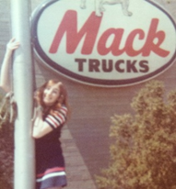
I have had the great fortune to know Sue for many years and continue to learn more and more about her all the time. Below she shares a little about herself along with what she is doing now and why she chose this field. She is truly a member you will enjoying meeting--Jennifer

I was fortunate to have had the opportunity to try out several careers before entering my current profession in the vision rehabilitation therapy field. Let me share some of my past work experiences and maybe you can figure out a pattern: I started out playing the organ/keyboard in a rock and roll band as a teenager, was secretary to the pathologist at a hospital taking dictation during specimen exams and autopsies, worked as a bookkeeper for Mack Trucks, barmaid at an Irish Pub, office manager at a Ford Dealer, and then eight years as a stay-at-home mom, soccer coach, scout leader, and Sunday School teacher. OK, so there’s no pattern here, as you can see.
When my youngest son was entering preschool, I decided that I should make an attempt to get back into the workforce. I went to a seminar at our local community college called something like, “The Non-Traditional Student.” Here I learned about the reentry program, how to recover college credits from the past, earn credits from testing and experience, etc. I took one class and then was hooked. With my previous college credits (where I was majoring in math), and by taking several CLEP tests, I moved on to the College of Education at Northern Illinois University. After starting in general special education, I moved into the Programs for Visual Disabilities since I had personal experience in this area because two of my three children have albinism.
I received my bachelor’s degree as a Teacher of Visually Impaired and worked in the public schools and in Early Intervention for several years. While doing this, I started in the Master’s Program for Multiple Disabilities, but then decided to go into Rehabilitation Teaching. So here I am today!

I received my VRT degree in 1996, and have been working in that general field since then. In 1999 I was offered the opportunity to start up a transition program for youth in Illinois, and began TransVision at that time. In my current job, I work with high school students, parents and professionals, addressing issues of independent living skills, vocational readiness, college preparation and social skills to promote successful transition from school to work. By conducting summer transition programs, community experiences, college preparation weekends and family workshops, I get the chance to spend time with the students and everyone involved in their lives to talk about these important issues for their future. I also enjoy working on research studies and giving presentations at a variety of conferences throughout the country.

One of the strangest coincidences during my career took place at a transition summit in the Pacific Northwest, where I began meeting with other transition specialists from that part of the country annually. These meetings were the absolute best resources for me in planning activities and programs for the teens in my program by learning all about the experiences and programs that other states were doing or had done over the years. While chatting with some of the other people there, we discovered that several of us were in “garage bands” back when we were in high school and college. And three of us all played the organ in the bands. (One band was even called “Blind Ambition!”) What a twist of fate! I still like to play music and really enjoy the fact that all of my kids (to various degrees) are musicians. A big highlight in the last few years was having a reunion with my band in Arizona where we rented amps and instruments and set up a jam session for an entire day, playing our songs from the past. I met again this past year with a couple of the guys for another gig in California. I’m all set to go for my next career! So exactly when is someone too old to want to be a rock star?
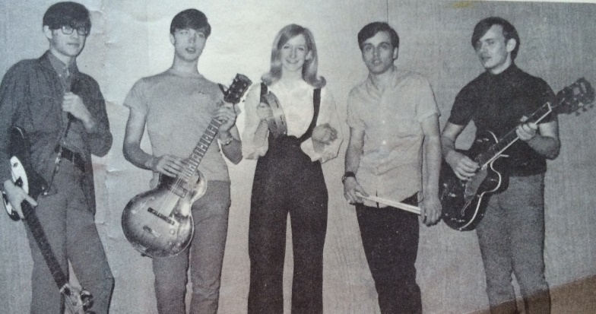
Before I even finished my VRT Degree, I was encouraged by my supervising teacher to join professional organizations. Yes, Jennifer Ottowitz first got me interested in MACRT and then through AER, I joined the VRT Division. Having the connection with other respected professionals in the field has been priceless. This is definitely a wonderful family of people who all share the love of what they do and are willing to pass along their expertise to others. I truly value not only the professional benefits of being part of the division but also the friendships that have developed over the years as well.
Photo: The Comin' Generation
Photo: The Comin’ Generation – the only band in our high school to have a female member! (You guess the year this was taken!) Five band members – Steve on bass, Larry on rhythm guitar and vocals, Sue in the middle with a tambourine (keyboard and vocals), Ed on drums, and Bob on lead guitar.

Funny, but I often ask others to share words of wisdom – and truly appreciate these – but when asked to give some of my own, it’s not as easy. Probably the ones that I say more to myself are something like: “OK, you did a good job on that task, now what can you do to make it even better the next time?” --or, “Start every day with music, a dance, and a prayer of thanks!”

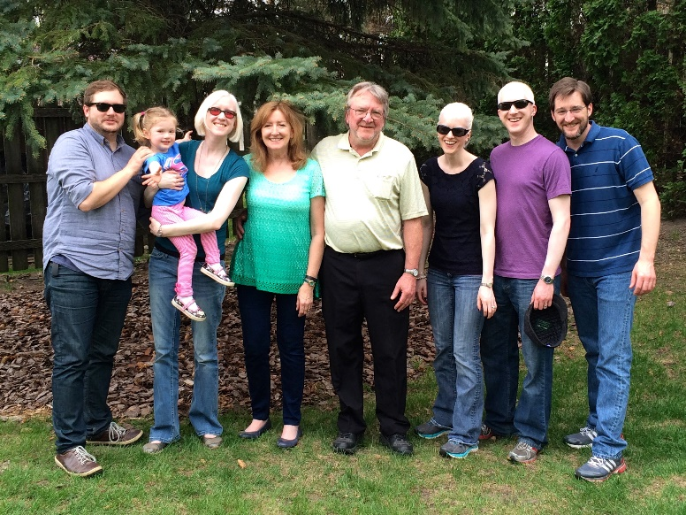
Photo: “The Dalton Gang” – Marengo, Illinois Branch
Left-to-right: James (son-in-law), Phoebe (granddaughter), Kelsey (daughter), me, Barney (husband), Kristen (daughter-in-law), Ed (son), Patrick (son)

Vision Rehabilitation Therapy Division Board

Contact information
Chair: Ian Shadrick, CVRT, CRC
E-mail: ianshadrick@hadley.edu
Chair-elect: Cammy Holway-Moraros, CVRT, LSW
E-mail: cmoraros@theiris.org
Secretary/Treasurer: Susan Dalton, CVRT
E-mail: susan.dalton@att.net
Past Chair: Jennifer Ottowitz, CVRT
Newsletter Editor
E-mail: jennifer@hadley.edu

Please let me know of any questions, concerns, errors, or comments that you have regarding the VRT newsletter. I also welcome any articles or ideas for articles that you may have. Best wishes for a happy, healthy, fun-filled and rewarding new year!

