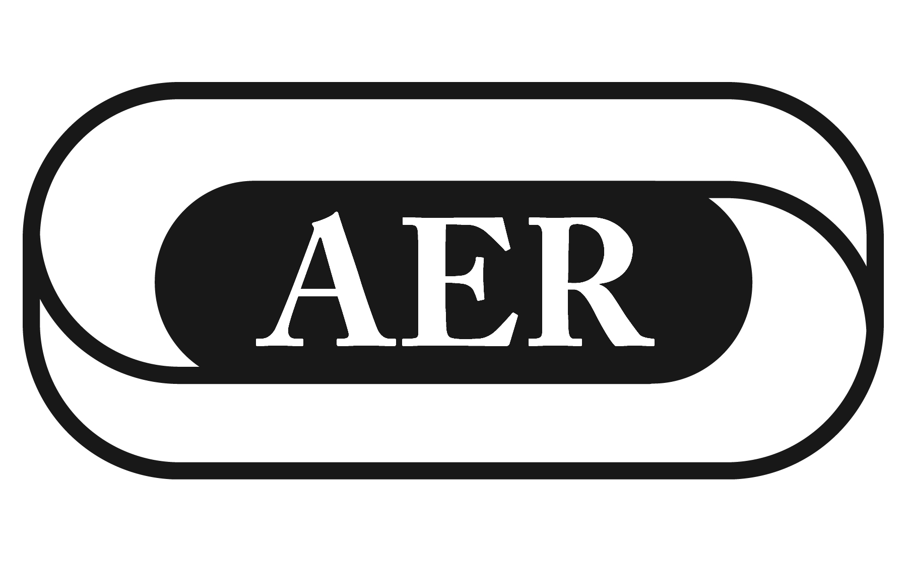
AER Multiple Disabilities and Deafblind Division
Samuel Gridley Howe Award for Outstanding Practice
Nomination Form

The Samuel Gridley Howe Award for Outstanding Practice is presented to a member of the division who has shown exemplary service to individuals with visual impairments and multiple disabilities, including deafblindness.

All recipients of Division 3 Awards must meet the following criteria:
- Have a longitudinal record of work in services to children youth and/or adults with deafblindness/multiple disabilities.
- Have gained the respect of peers, professionals from other disciplines, and the families and individuals served.
- Be a member of a discipline (e.g., education, rehabilitation, medicine, social work, health-related professions, etc.) that has a direct impact on individuals with deafblindness/multiple disabilities.

The qualities we seek in nominees are:
- Demonstrated competence in the field.
- Development or implementation of innovative approaches in the field.
- Recognized contribution to the theory or practice of working with individuals with deafblindness/multiple disabilities.
- Willingness to share knowledge with others.

Additional requirement for the Samuel Gridley Howe Award: This award is for an individual who has demonstrated outstanding practice working with individuals with deaf-blindness/multiple disabilities.

I would like to nominate: (Please complete a separate nominations form for each award/nominee)

Name:
Address:

Principal Nominator:
Address:
Telephone Number:
*In order to nominate an individual for an award, you must be a current member of AER.

Please write a brief statement in support of you nominee:

____________________________________________________________________________________________________________________________________________________________________________________________________________________________________________________________________________________________________________________________________________________________________________________________________________________________________________________________________________________________________________________________________________________________________________________________________________________________________________________________________________________________________________________________________________________________________________________________________________________________________________________________________________________________________________________________________________________________________________________________________________________________________________________________________________________________________________________________________________________________________________________________________________________________________________________________________________________________________________________________________________________________________________________________________________________________________________________________________________________________________

Please return form to: AER Multiple Disabilities and Deafblind Division
Chair Elect, Kristi Probst
Via email
All Nominations Must be received by April 15th of the International Conference Year

